Nepal College of Information Technology

**Unit Test**

Fall 2013

Program : BE IT Time : 2 hrs

Semester : (V) FM : 70

Subject : Signal System Processing PM : 35

* *Candidates are requested to give their answer as far as practicable in their own words.*
* *The figure in the margin indicates the full marks*
* ***Attempt ALL question***

1. What do you mean by linear time-invariant system? Explain it with appropriate examples.Check whether the following system is linear time-invariant or not. y[n]=nx[n] [7]

2. Define convolution.Obtain convolution sum of [8]

i)x[n]=1 for -1≤n≤1 ii)h[n]=1 for -1≤n≤1

0 otherwise 0 otherwise

3. Describe causal and non-causal system along with an example of each. [5]

4. Define the following terms:Cut-off frequency,Attenuation, Stop Band, Roll-off factor [8]

5. The following specifications are given for butterworth low-pass filter: [10]

αmax=0.5dB αmin=20dB fp=0.159KHz fs =0.318KHz

Determine i) Filter order ii) Location of poles and zeros iii) Half power frequency

iv) Attenuation at w=1500 rad/s v) Quality factor

6. Determine the location of chebyshev poles and transfer function for n=3 and αmax =1dB [8]

7. Find BPF using frequency transformation for given LPF network. [7]

Given w1=105 rad/sec, w2=4×105 rad/sec where w1 and w2 are the frequencies of BPF

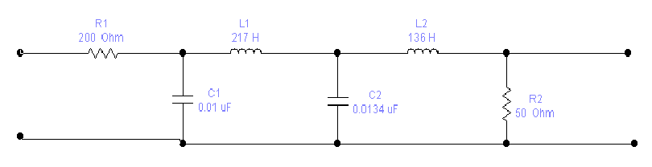

8. Design an active filter with transfer function T(s)=k/(s+P1) [7]

9. Write short notes on:(Any two) [10]

a) Discrete Time Fourier Series

b) Periodic and Aperiodic Signals

c) Signum Function

d) Analog Filter Design